**HANOI UNIVERSITY OF INDUSTRY**

**FACULTY: INFORMATION SYSTEM**

**------------------------------**



**FINAL PROJECT REPORT  
COURSE: INTRODUCTION TO SOFTWARE ENGINEERING**  
Topic:  
Research on the waterfall model and write a specification document for the "Bookstore Website" project of Nha Nam bookstore.

**Instructors**: Ts Vũ Đình Minh

**Students perform** :Team 4

Đỗ Thị Huyền

Nguyễn Huy Nam

Nguyễn Thị Bích Ngọc

Trương Thị Thủy

**Class**: 20212IT6082002

**Faculty**: Information system

Table of Contents  
INTRODUCTION 1  
CHAPTER 1: RESEARCH ON THE WATERFALL MODEL 2  
1.1 The Waterfall Model 2  
1.1.1 Introduction to the Waterfall Model 2  
1.1.2 Phases of the Model 2  
1.1.3 Advantages and Disadvantages 3  
1.1.3.1 Advantages 3  
1.1.3.2 Disadvantages 4  
CHAPTER 2: SPECIFICATION 5  
2.1 System Survey 5  
2.1.1 Preliminary Survey 5  
2.1.1.1 Objectives 5  
2.1.1.2 Methodology 5  
2.1.1.3 Subjects of Survey 12  
2.1.1.4 Preliminary Results 12  
2.1.1.5 Collected Documents 13  
2.1.2 Detailed Survey 19  
2.1.2.1 System Activities 19  
2.1.2.2 Functional Requirements 20  
2.1.2.3 Non-Functional Requirements 22  
2.2 Data Modeling 23  
2.2.1 Data Requirements 23  
2.2.2 Logical Data Entity-Relationship Diagram 24  
2.2.3 Physical Data Model 24  
2.2.3.1 Table Design 24  
2.2.3.2 Physical Entity-Relationship Diagram 28  
2.3 Functional Modeling 29  
2.3.1 Use Case Diagram 29  
2.3.1.1 Main Use Cases 31  
2.3.1.2 Sub Use Cases 33  
2.3.1.3 Decomposition of Some Use Cases 34  
2.3.2 Detailed Use Case Descriptions 35  
2.3.2.1 Description of "View Books by Category" Use Case 35  
2.3.2.2 Description of "View Bestselling Books" Use Case 36  
2.3.2.3 Description of "View Promotions" Use Case 37  
2.3.2.4 Description of "View Special Discounts" Use Case 38  
2.3.2.5 Description of "View Authors" Use Case 39  
2.3.2.6 Description of "View Translators" Use Case 40  
2.3.2.7 Description of "View Publishers" Use Case 41  
2.3.2.8 Description of "Search Books by Name" Use Case 42  
2.3.2.9 Description of "Register" Use Case 43  
2.3.2.10 Description of "Login" Use Case 44  
2.3.2.11 Description of "View Transaction History" Use Case 45  
2.3.2.12 Description of "Check Order" Use Case 46  
2.3.2.13 Description of "Manage Shopping Cart" Use Case 47  
2.3.2.14 Description of "Payment (Place Order)" Use Case 49  
2.3.2.15 Description of "Maintain Book Categories" Use Case 50  
2.3.2.16 Description of "Maintain Books" Use Case 52  
2.3.2.17 Description of "Maintain Book Genres" Use Case 53  
2.3.2.18 Description of "Maintain Authors" Use Case 55  
2.3.2.19 Description of "Maintain Translators" Use Case 57  
2.3.2.20 Description of "Maintain Publishers" Use Case 59  
2.3.2.21 Description of "Maintain Book Introductions" Use Case 61  
2.3.2.22 Description of "Manage Accounts" Use Case 63  
2.3.2.23 Description of "Manage Orders" Use Case 64  
2.3.2.24 Description of "Login" Use Case 66  
CHAPTER 3: CONCLUSION 67

1. **INTRODUCTION**  
   Entering the digital age - the 21st century, humans are increasingly achieving significant achievements thanks to the Fourth Industrial Revolution and information technology (IT) becoming an important factor, strongly impacting all fields. The development of IT and its outstanding results have elevated the issues of innovation and creativity in the digital age to a new level, which is a matter of survival for any individual or organization.

On the other hand, with the development of the economy, people's lives are increasingly improving, and the buying and selling needs of people are increasing. The competition between suppliers and stores is becoming more intense. To meet the needs of customers, online sales have become more developed, with a wide range of services, simple advertising, easy-to-use, and can meet the needs of customers at any time of access.

From that need, our group has chosen the topic "Research on the waterfall model and write a specification document for the project "bookstore website" of Nha Nam publishing house" to make shopping simple, save time for buyers.

Within the limited time and knowledge, our work certainly has many shortcomings. We sincerely hope to receive the comments and guidance of the teachers to make our work more complete.

We would like to express our gratitude to Mr. Nguyen Duc Luu - who has dedicatedly guided and helped us in the process of completing this project. We sincerely thank you

CHAPTER 1  
**Water treatment process model - An Overview**

# The Waterfall model

### Introduce about the Waterfall model

### The Waterfall model is the first introduced Process Model. It is also known as the linear sequential model. It is very simple to understand and use. In the Waterfall model, each phase must be completed before the next phase can begin and there is no overlap in the phases. Waterfall is the first and most well-known process model introduced, with the oldest approach to System Development Life Cycle (SDLC) used to develop software. The Waterfall model illustrates the process of software development in a linear sequential flow. This means that any stage in the development process only begins if the previous stage is completed. In the Waterfall model, the phases do not overlap.

### Phases in the Waterfall model

- Requirement Analysis: All possible requirements of the system being developed are recorded in this phase and documented in the requirements specification document to serve the following phases

- System Design: The technical specifications requirements from the initial stage are studied in this phase and system design is prepared. This system design helps to identify the hardware and system requirements as well as determining the overall system architecture

- Implementation: Based on the input from the system design, the system is first developed in small programs called units, which are integrated in the next phase. Each unit is developed and its functionality is tested (also known as Unit Testing).

- Integration and Testing: All units developed in the implementation phase are integrated into a system after testing of each unit. After integration, the entire system is tested for any errors and malfunctions (this phase is also known as Integration Testing).

- Deployment of system: After functional and non-functional testing is performed, the product is deployed to the customer environment or released to the market.

- Maintenance: There may be some issues that occur in the customer environment. To address those issues, bug fixes are released. Additionally, to improve the product, some better versions are released. Maintenance is carried out to bring these changes into the customer environment.

.

**The Waterfall SDLC model is used when:**

* Stable and unchanging requirements are expected.
* The application is small in size.
* There are no ambiguous or unclear requirements
* The environment is stable.
* The tools and technologies being used are stable.
* The resources are trained and readily available

1. Advantages and Disadvantages

#### Advantages

- This is a simple model that is easy to apply, with a clear process divided into steps.

- It is easy to manage and maintain by using a linear approach and fixed steps.

- Input and output criteria are clearly defined, making it easy to check for quality control.

- It operates efficiently in small projects with clear requirements.

- There are many resources available for customers

#### Disadvantages

- It is not an ideal model for large and long-term projects.

- It is not effective for projects facing unclear requirements from the outset.

- It is difficult to adapt to changes, including requirements, plans, project scope, etc.

- It has low visual appeal and slow value delivery, as users only see and use the product at the end of the cycle.

# CHAPTER 2: SPECIFICATION

### System survey

#### Preliminary survey

#### Objective

* The bookstore wants to expand its market by selling books on various e-commerce platforms to keep up with the latest trends, reach out to younger customers, and overcome the difficulty of direct selling due to the impact of the Covid-19 pandemic.
* This will enable the bookstore to easily reach a wider audience, and customers can buy books without having to go to the physical stores.
* Customers can view information about books, best-selling books, check prices, purchase books, and track their orders.
* On the Admin side, they can monitor buying and selling activities on the system, add, edit, and delete information about books, update new types of books to the system, confirm customer payments and orders.

#### Method

* Interview
* Interview plan

|  |  |
| --- | --- |
| Interview plan | |
| Interviewee: Nguyễn Thị Bích Ngọc | Interviewer: Đỗ Thị Hyền |
| Address: Nhã nam Bookstore | Appointment time: 8h  Start time: 8h30  End time : 9h |
| Target audience:  Interviewee: Bookstore employee  Data collection:   * Revenue * Types of books * Popular books * Customer satisfaction   Agree: Ensure that all information is accurate. | Bookstore employee: has the role of advising customers, answering questions, and handling payments.  They are professionally trained in the field |
| Program:   * Introduction * Overview of the project * Overview of the interview * Topics to be discussed, permission to record * Topic 1: Questions and answers about the bookstore * Topic 2: Questions and answers about   Summarize the main content and opinions of the interviewee  Conclusion. | Estimated time:   * 1m * 2m * 1m * 7m * 10m * 2m * 1m |
|  | Total estimated time: 30p |

* Interview form

|  |  |
| --- | --- |
| Interview form | |
| Project : | Sub-project: |
| Interviewee : Nguyễn Thị Bích Ngọc | Interviewer: Đỗ Thị Huyền  Date : 19/3/2022 |
| Questions | Note |
| Question 1: Have you ever shopped online before?  If so, what do you think about buying books online? | Answer:  Yes.  It is faster and more convenient. It also ensures the quality of the products. |
| Question 2: What are the groups of people who frequently make purchases? | Answer:  Children, students, young adults, and elderly people are some of the groups that frequently make purchases. |
| Question 3: What type of books are most popular and purchased by customers? | Answer:  The popularity and sales of different types of books vary depending on the time  For example:  - At the beginning of the school year, textbooks are sold in large quantities. |
| Question 4: What strategies does the bookstore have to retain existing customers and attract new ones? | Answer:  - Firstly, the service attitude of the staff is a prerequisite for retaining and attracting customers.  - For existing customers, discounts are given based on the quantity of products purchased in one transaction.  - Always have products that keep up with market trends. |
| Question 5: Have you encountered any difficulties during your work? If so, what are they? | Answer:  Yes. Sometimes, I cannot meet the needs of customers. I have to have a broad knowledge of books to be able to advise customers. I need to have good communication skills with customers. |
| Question 6: Would you like to sell products online? If so, what kind of system do you prefer? | Answer:  Yes. The book classification system is clear, and customers always see the most searched and best-selling products. There is detailed information for each book, and it is easy to use. |
| Question 7: What channels do customers use to contact and communicate with the bookstore? | Answer:  -Through the bookstore's fanpage, hotline, and website. |
| Question 8: Do customers who buy books online receive the same benefits as those who buy directly from the bookstore? | Answer:  Yes.  The discount will depend on the quantity of products that the customer purchases. |
| Question 9: Do you want the system to suggest the types of books that customers often search for? Why? | Answer:  - Yes.  It helps customers not to hesitate in choosing products. |
| Question 10: What do you think about the workload of selling books online compared to selling them directly? | Answer:  - I think the workload of selling products online will be lighter. It is easier to manage the products sold and imported. |
| Question 11: Can you ensure that customer information is kept confidential? | Answer:  - Only authorized personnel have access to customer information. |
| Question 12: Do you want customer reviews to always be displayed along with product information? | Answer:  - That helps customers know the quality of the product they want to buy. |
| Question 13: What competitive advantages does the bookstore have when it has an online sales system? | Answer:  - It helps customers have more payment options and achieves the goal of expanding the market. |
| Question 14: How will you handle it if a product is damaged during transportation? | Answer:  - Customers can check the product before making payment, and if any issues arise, the system will support exchange and return within 7 days. |
| Question 15: What benefits will using management software bring in terms of reducing personnel costs? | Answer:  - Eliminates the step of recording customer and product information. |
| Question 16: If the system is launched, will it bring real business benefits to the bookstore? | Answer:  Yes.  Because statistics show that stores using management software have increased revenue in different periods. |
| General evaluation:   * The interviewee was enthusiastic in sharing information. * The amount of information provided was quite complete. * The interviewee has knowledge about online sales. | |

Survey form.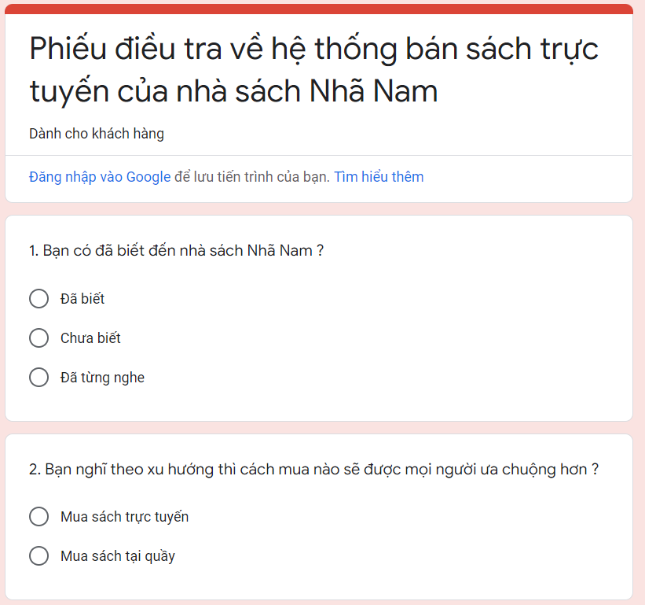

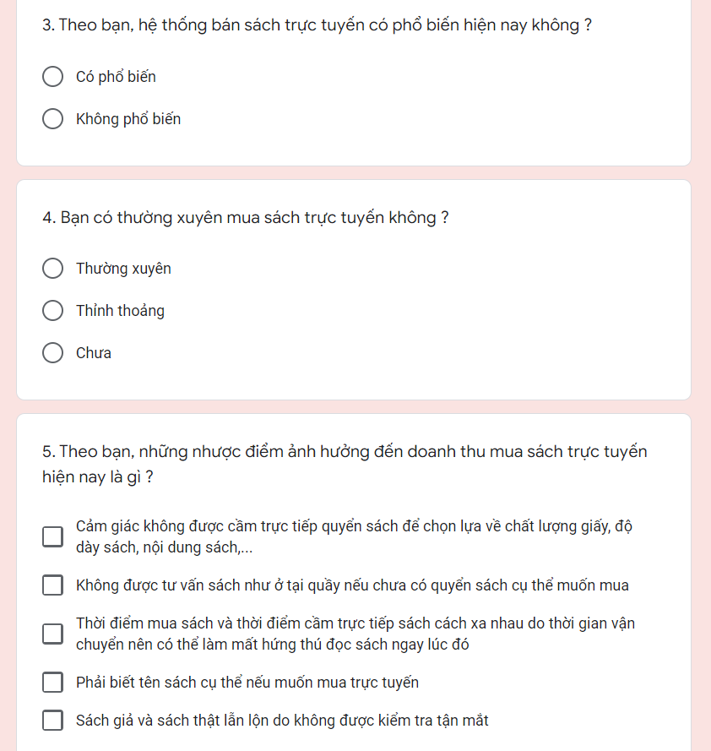

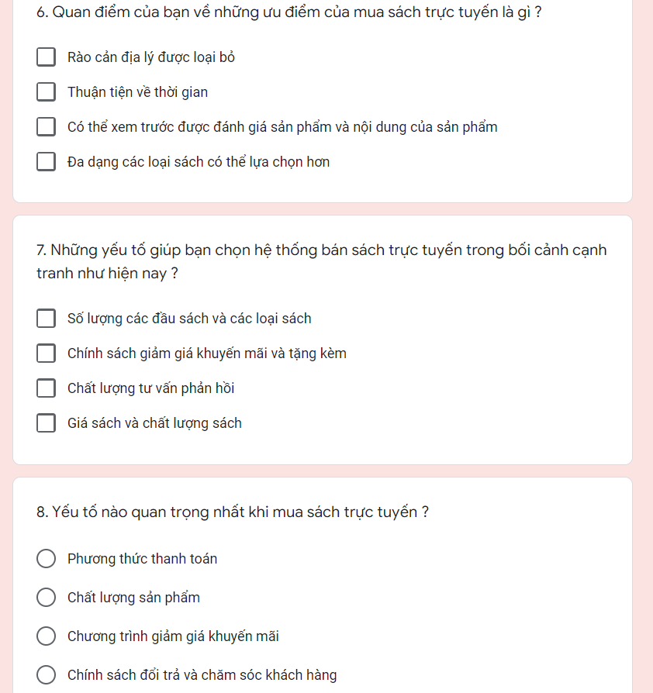

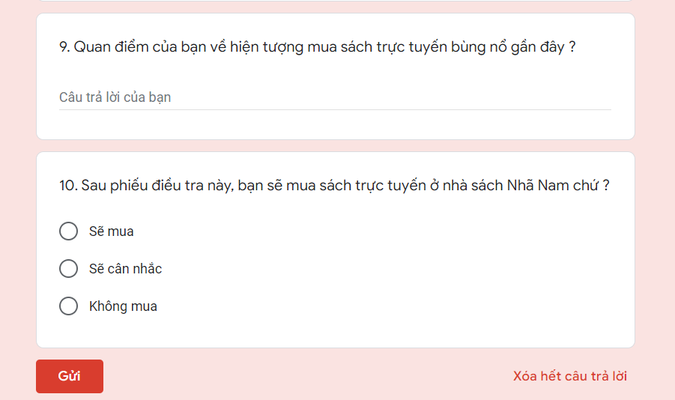

**Observation:**

Management of book purchase registration: When customers want to buy books, they can come directly to the bookstore, choose books (or ask the staff for advice on book genres to buy), and then contact the bookstore manager to proceed with the book purchase procedure. The staff will check the book price and collect payment.

In the case of customers who want to rent books, the staff will collect personal information from the customer (name, phone number, address, ID card/passport number for foreign customers) and proceed with the rental registration.

#### Survey target

*- Sales staff* : responsible for completing payment, registering book rentals for customers, and receiving books back when customers return them.

*- Consultation staff*: receive customer requests, introduce, advise, and answer customer questions.

#### Preliminary results

Nha Nam bookstore is located at 59 Do Quang, Trung Hoa Ward, Cau Giay District, Hanoi. It was established in February 2005, and the full name is Nha Nam Culture and Communications Corporation, entering the book market. "Balzac and the Chinese Seamstress" by Dai Sijie was the first book published by the Nha Nam founders before the company was established. After the first book, readers have been interested in and loving a new book brand, with the desire to contribute to creating a new face for literature publishing in Vietnam. The passion of the whole team is the first stone. After a few years of development, Nha Nam has gradually built an image of a professional and strong publishing house. Six months after the company was established, "The Diary of Dang Thuy Tram" was born, with nearly 500,000 copies sold, causing a sensation in society and breaking all previous publishing records, with some important impacts on the public and society.

Some business activities :

● Online ordering  
● Get questions answered by bookstore staff  
● Have vouchers for promotions and book discounts on special occasions.  
▪ For example, on Vietnamese Women's Day October 20:  
▪ + Get an additional 10% discount when using the code PNVN2019  
▪ The program applies to orders generated from October 15, 2019, to October 20, 2019.

●Various payment methods suitable for both domestic and international customers  
● Various forms of transportation, safe and secure, ensuring that all information about orders is kept confidential  
● Support for canceling and exchanging orders in case of incidents.

#### Collected documents:

1. Payment form.

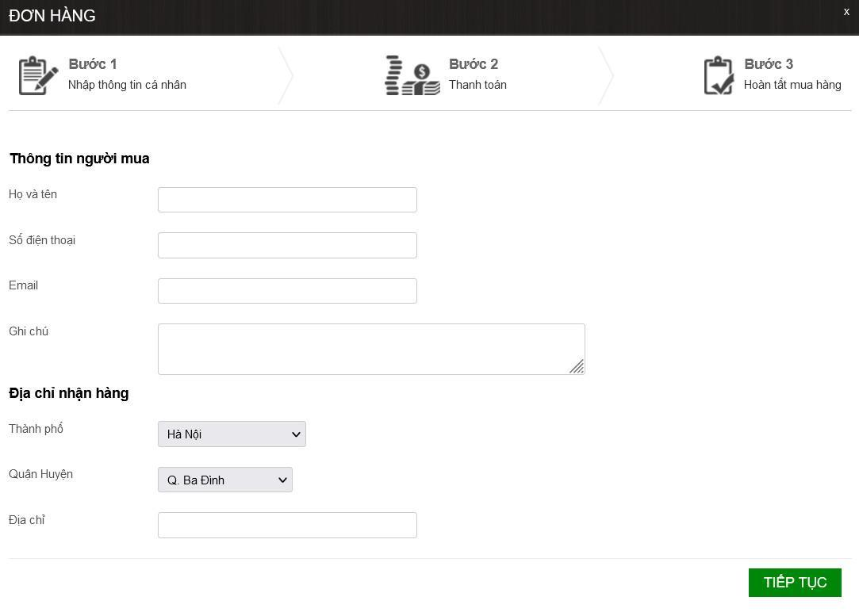

* Book details

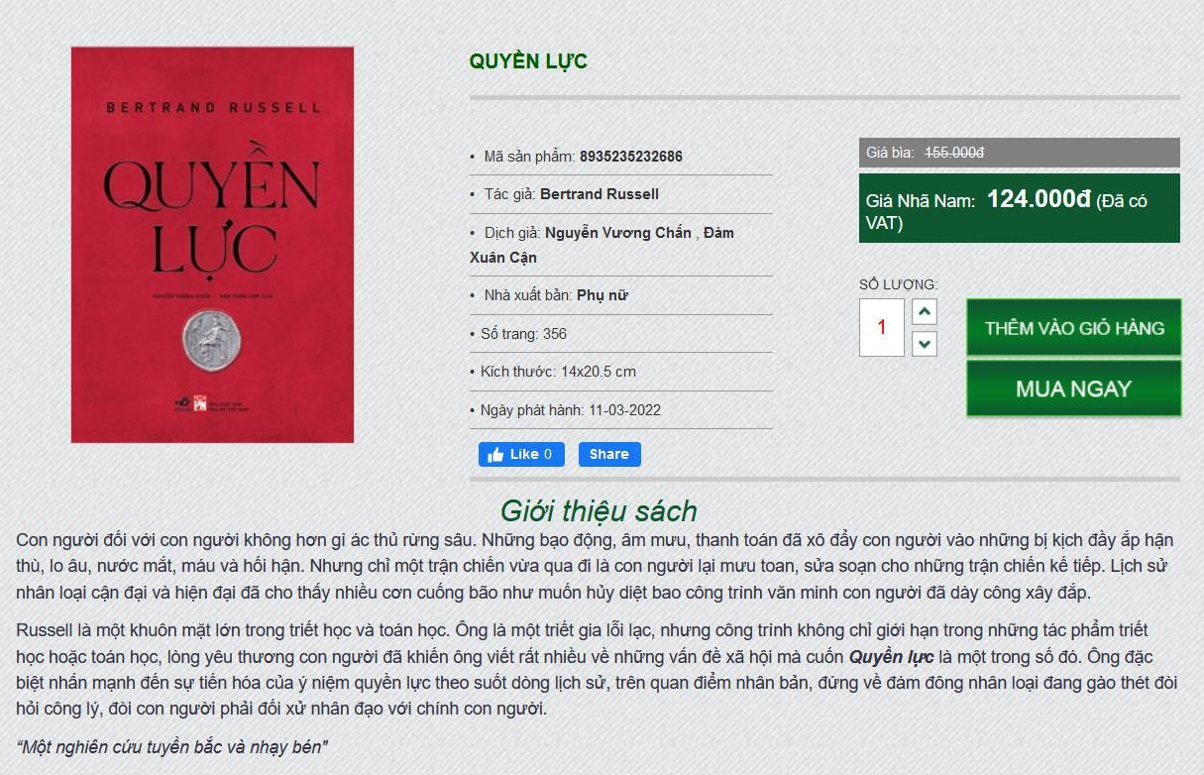

* Catalogue

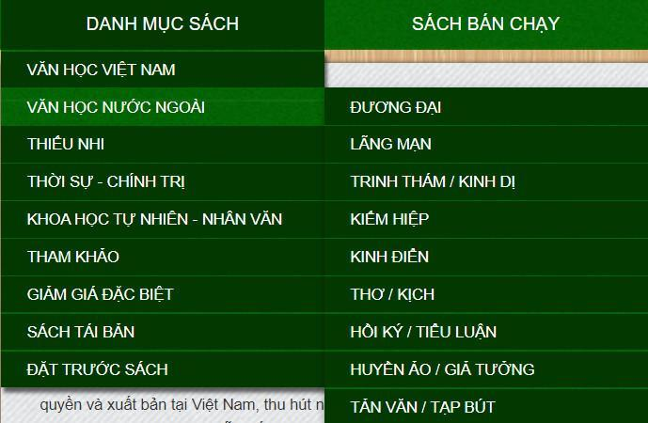

* Best-selling books always at the top of the page



* Promotional programs and special discounted books

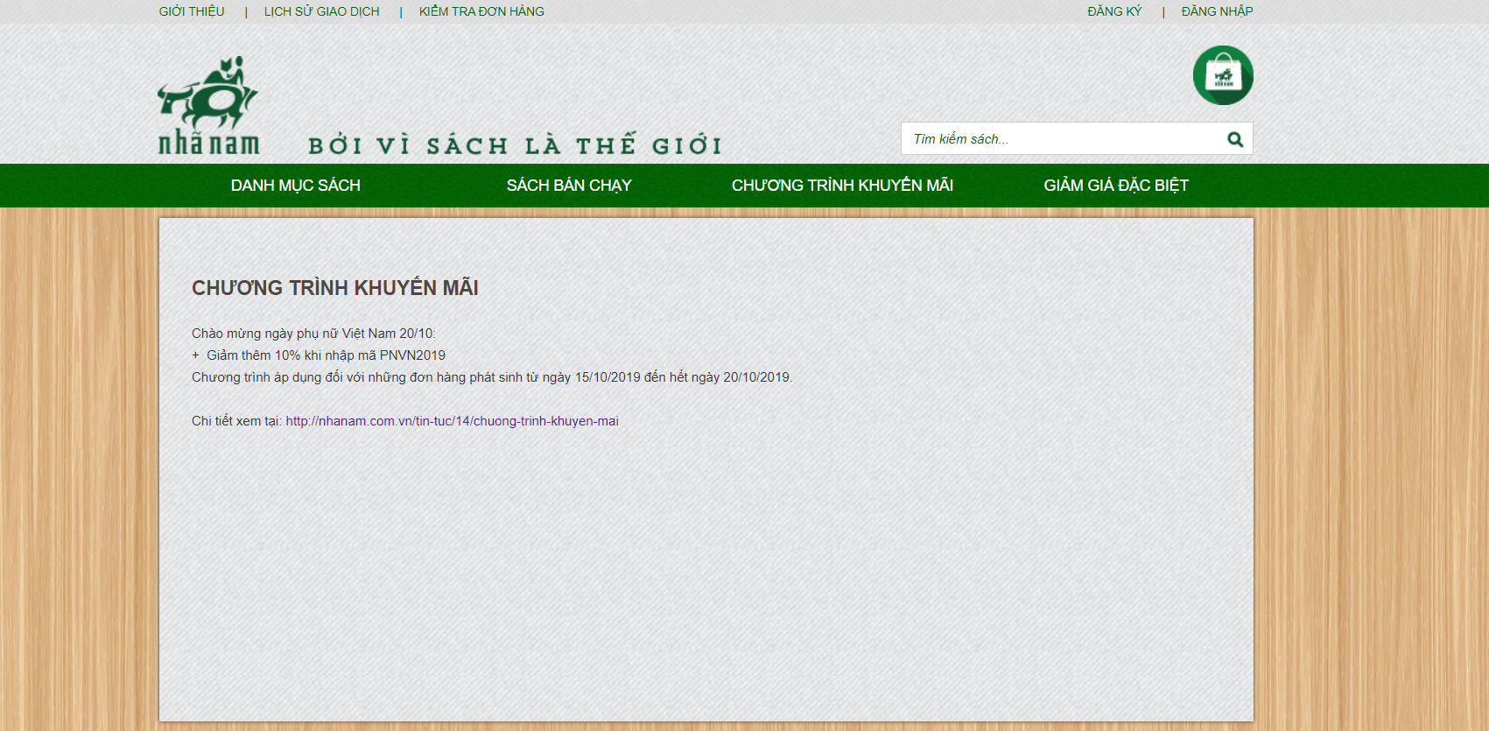

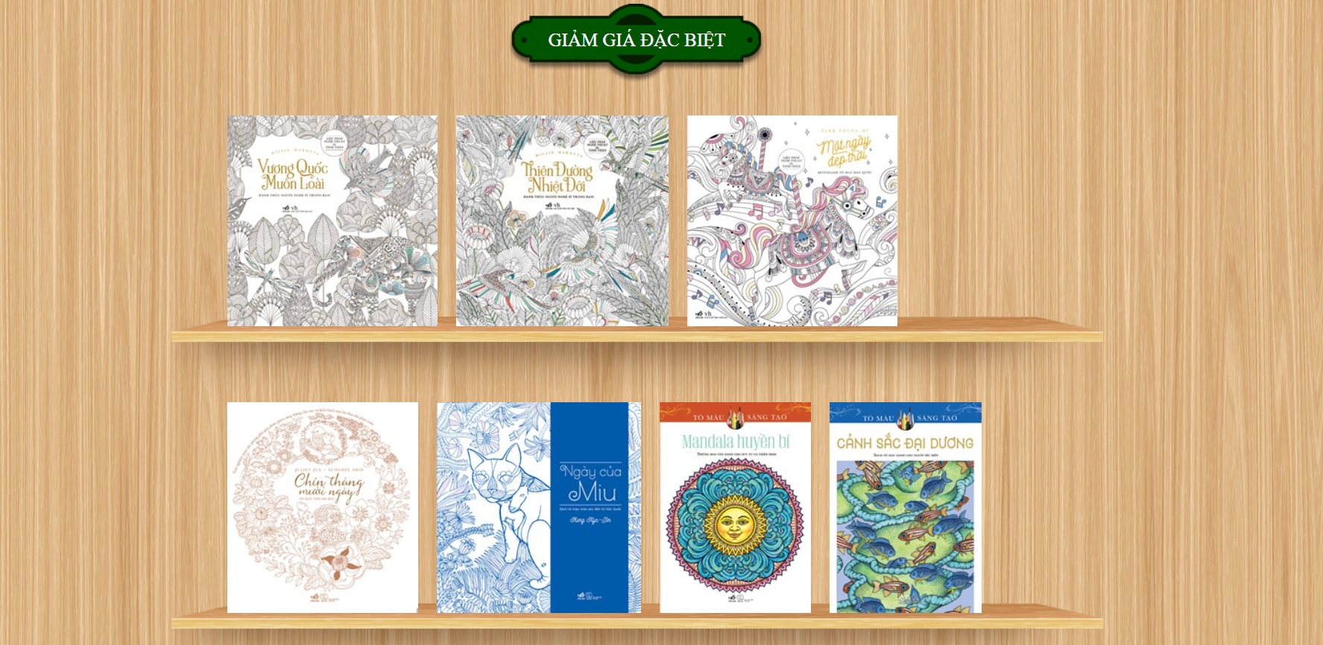

* Order tracking by entering a code

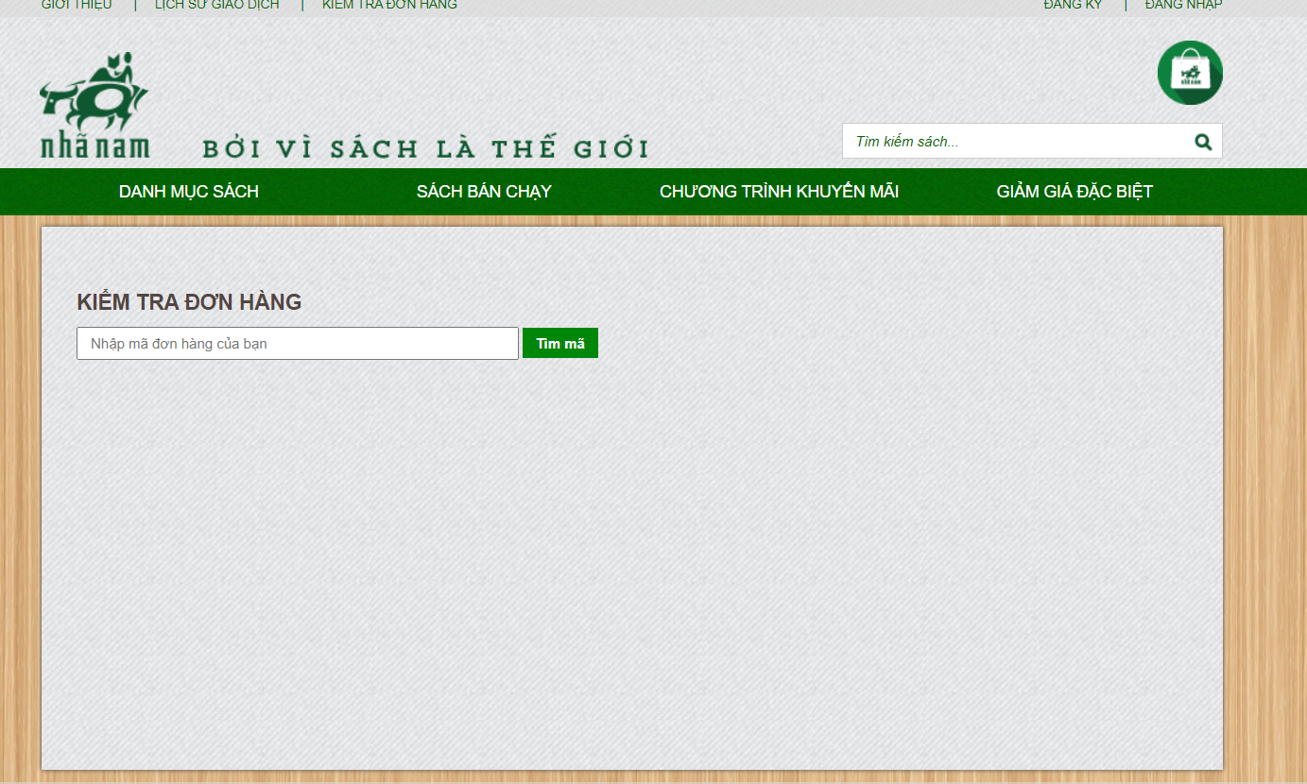

* Transaction history checking

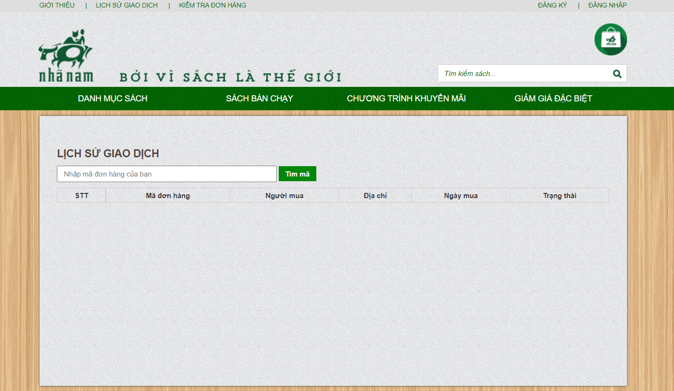

* Book search by title

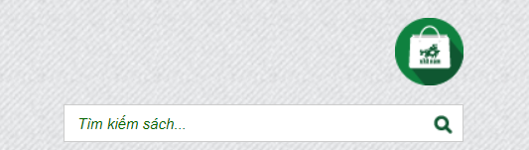

* Various forms of transportation for online purchases

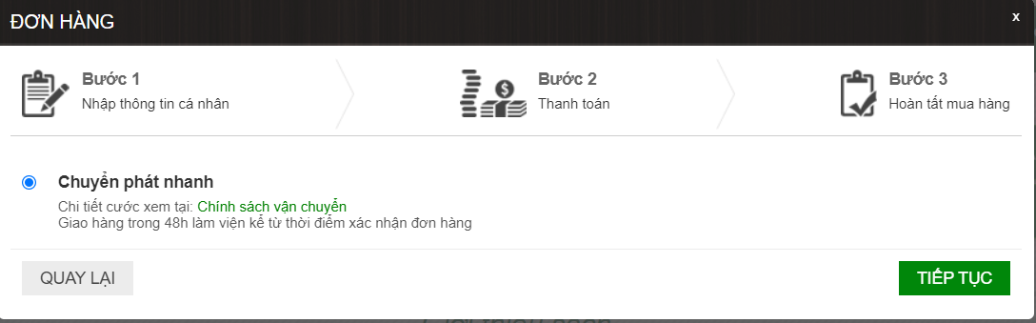

Completing purchases

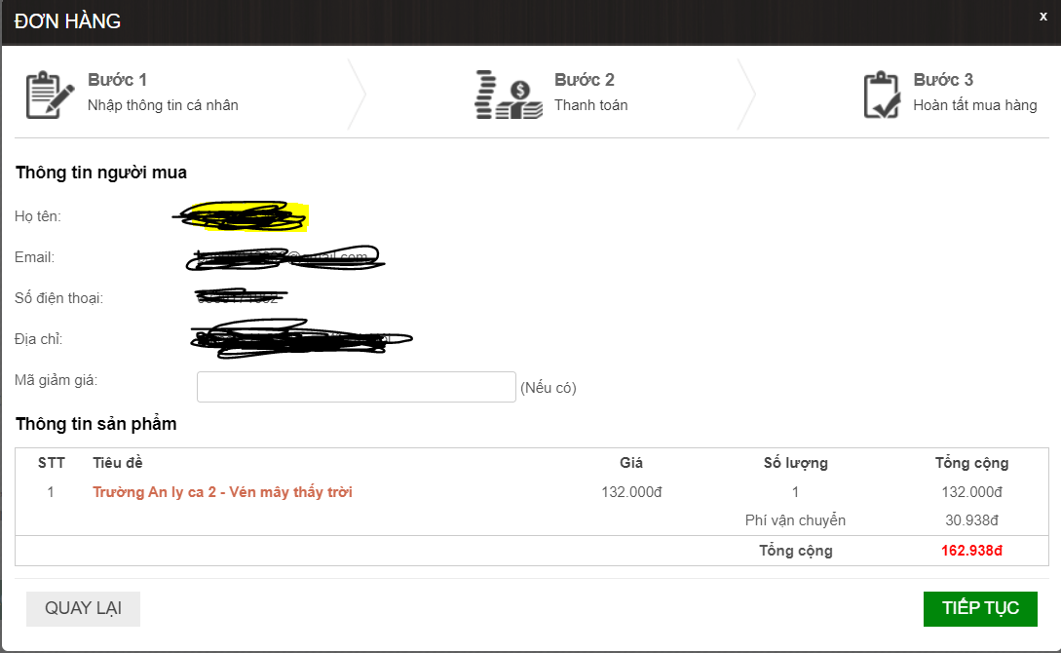

- VIP membership cards

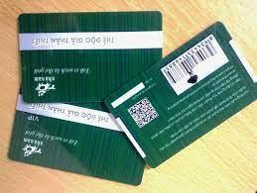

- purchase receipts.

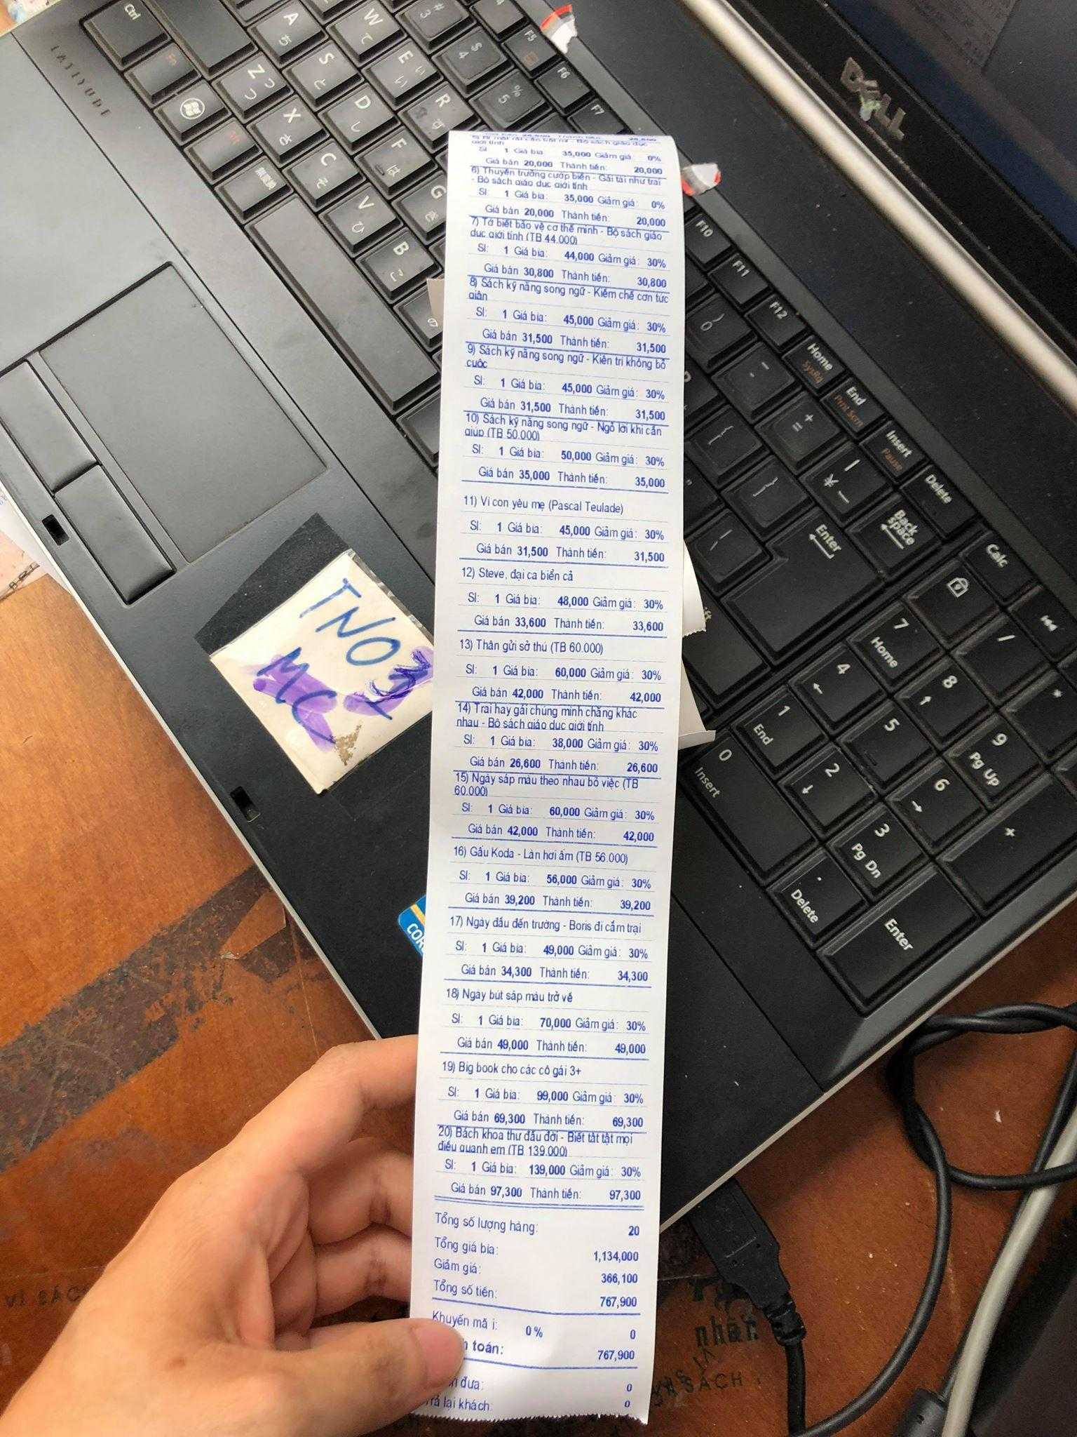

#### Detailed survey

#### System operation

- Product management: Admin can add, edit, and delete product information, control the quantity of products sold and purchased.

- Customer management: Store customer information for book purchases.

- Order management: Manage information about orders, payments, and order status (delivered, undelivered, processing) for revenue statistics.

* + - 1. **Functional requirements**

-The bookstore management software aims to apply information technology to solve business issues and serve bookstore management.

-Manage information about customers, employees, services, promotions, discounts, etc.

-Manage business activities of the store, handle incidents, and report revenue.

-Help customers easily search for products and find information about them.

-Customers can access the website and perform functions such as: +) Browse books by category

+)Browse best-selling books

+)View promotions

+)View special discounts

+)View authors

+)View translators

+)View publishers

+)Search for books by name

-Register

-Login

-View transaction history

-Check orders

-Manage shopping cart

-Payment (place order)

-Bookstore employees can log in with the following privileges:

+)Maintain book categories

+)Maintain books

+)Maintain book genres

+)Maintain authors

+)Maintain translators

+)Maintain publishers

+)Maintain book introductions

+)Manage accounts

+)Manage orders

+)Login

-Whenever a customer places an order, the system will automatically record the orders, and employees will update the order status (accepted or canceled) and notify the customer through notifications or the order checking function.

**Notification function**

* The notification function allows management to know when there are orders for products and when customers have successfully made payments.
* Notify customers about ongoing promotions, new books, and best-selling books. Check their order status.

**Search function**

* The search function helps management know details about products or customers, so they can closely monitor product quality and customer issues if any arise, etc.
* Help customers easily search for information about books by name. The system also supports book categories so that customers can choose their favorite genres.

**Online support function**

Management can directly communicate with customers about their requests and complaints about services, as well as provide support and advice to customers on their desired requests.

**Payment function**

* Notify management about the books that customers have purchased and the services that customers have requested, and provide the cost that customers must pay to facilitate payment processing.
* Customers can choose payment methods suitable for their conditions. The website supports all payment methods suitable for all user groups.

**Order checking function**

-Customers can check their orders to see if they have been accepted or canceled. Customers can also check their information and shipping addresses.

**2.1.1.4 Non-functional requirements**

-The system is compatible with all types of operating systems and web browsers such as (IOS, Android, Google Chrome, Cốc Cốc, Firefox, Microsoft Edge, etc.)

-Built on HTML, CSS, Node Js.

-The database is built on Microsoft SQL Server.

-The server has sufficient capacity to store information about the system and customers, thereby preventing overload situations.